Ahmad Joudeh (2010s)

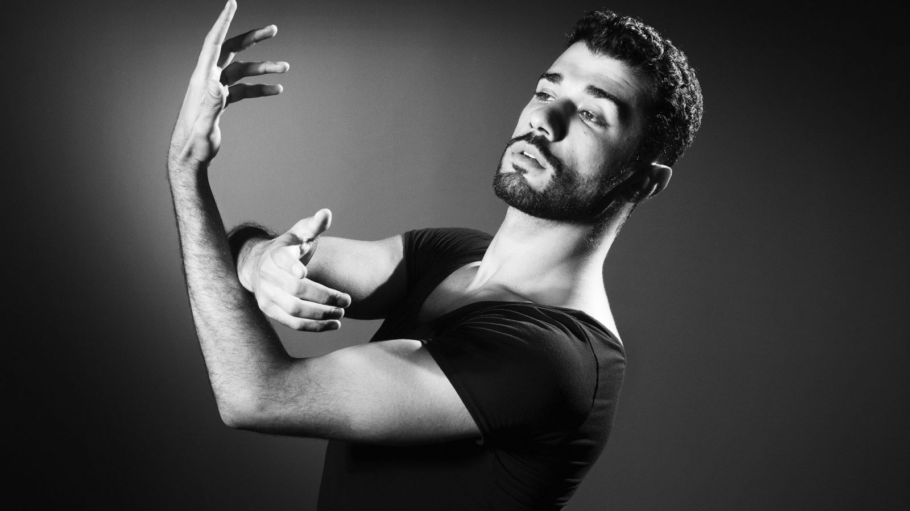
The outbreak of the Syrian civil war in 2011 left many without a home and claimed the lives of half a million people over the past decade. Ahmad Joudeh - a now internationally renowned Syrian-Palestinian ballet dancer and choreographer - was one of the children whose life was severely affected by the conflict. Joudeh’s home was destroyed by a bomb and he lost several relatives.

The war also became an obstacle to fulfilling his dreams of becoming a ballet dancer - a pursuit considered to be unsuitable for men in his country. With the rise of religious extremism, dancing in Syria became so dangerous that Joudeh faced execution if he was found practising. Despite the risks, Joudeh joined a Syrian ballet company and participated in international dance competitions, using dance as a way to fight Isis.

Joudeh’s social media account captured the attention of a Dutch journalist in 2016, who was inspired by Joudeh’s story and created several documentaries about him. The documentaries caught the attention of the Dutch National Ballet Company, which helped Joudeh move to the Netherlands to join them as a dancer. In 2021, Joudeh obtained Dutch citizenship. He now travels the world as a freelance dancer. Joudeh is distinguished by his unique dancing style, combining classical ballet with Arabic tradition.

In addition to his international acclaim as a dancer, Joudeh is a keen advocate for human rights. He was appointed International Friend by SOS Children's Villages International, where he taught disadvantaged children to dance and achieve their dreams. Joudeh has also organised numerous charity shows, raising money for children in Syrian refugee camps.

Joudeh sees his story as a way of giving people a voice. His motto is: “if you believe in yourself and keep on working, you can be what you want to be, no matter which label is placed on you, ‘refugee’ or ‘stateless’”.

Image credits: Joel Saget (article), Rogier Bos (infographic)

